SURE TRUST
ASSIGNMENT 1

Name:-B.Mounika
Trainer Name:-Harshee Pitroda
Course Name:-Python in Machine Learning
Date:-24-05-2022
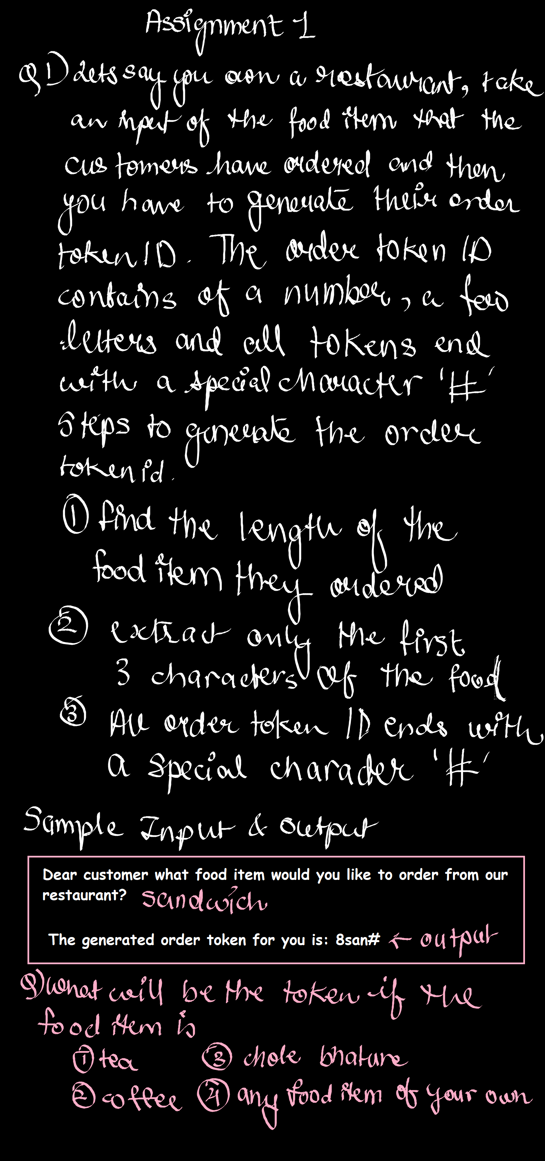
Q)
1)Coding for tea
Input:-
fooditem=str(input("Dear customer what food item would you like to order from our restaurant? "))
l=len(fooditem)
s=fooditem[:3]
c=str(l)
r=c+s+'#'
print("The generated order token for you is:",r)
Output:-
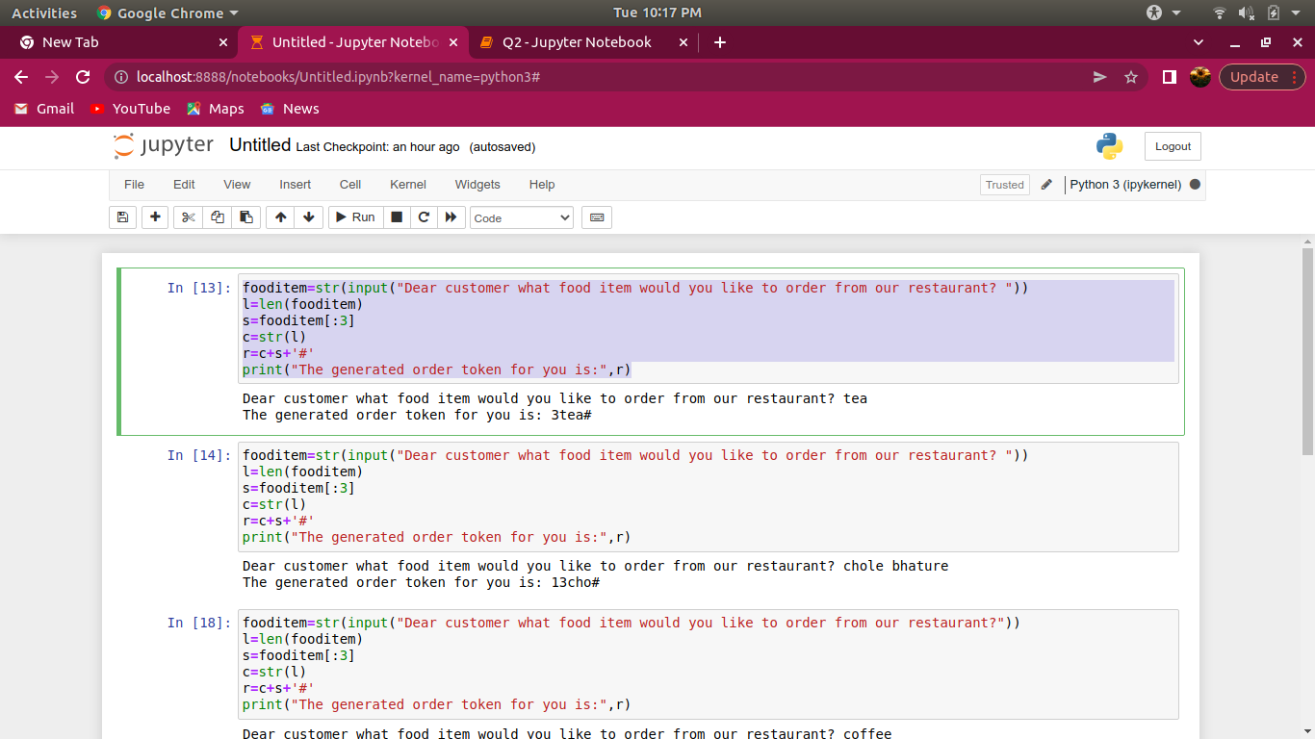
Dear customer what food item would you like to order from our restaurant? tea
The generated order token for you is: 3tea#

2)Coding for Chole bature

Input:-
fooditem=str(input("Dear customer what food item would you like to order from our restaurant? "))
l=len(fooditem)
s=fooditem[:3]
c=str(l)
r=c+s+'#'
print("The generated order token for you is:",r)
Output:-
Dear customer what food item would you like to order from our restaurant? chole bhature
The generated order token for you is: 13cho#

3)Coding for coffee

Input:-
fooditem=str(input("Dear customer what food item would you like to order from our restaurant?"))
l=len(fooditem)
s=fooditem[:3]
c=str(l)
r=c+s+'#'
print("The generated order token for you is:",r)

Output:-
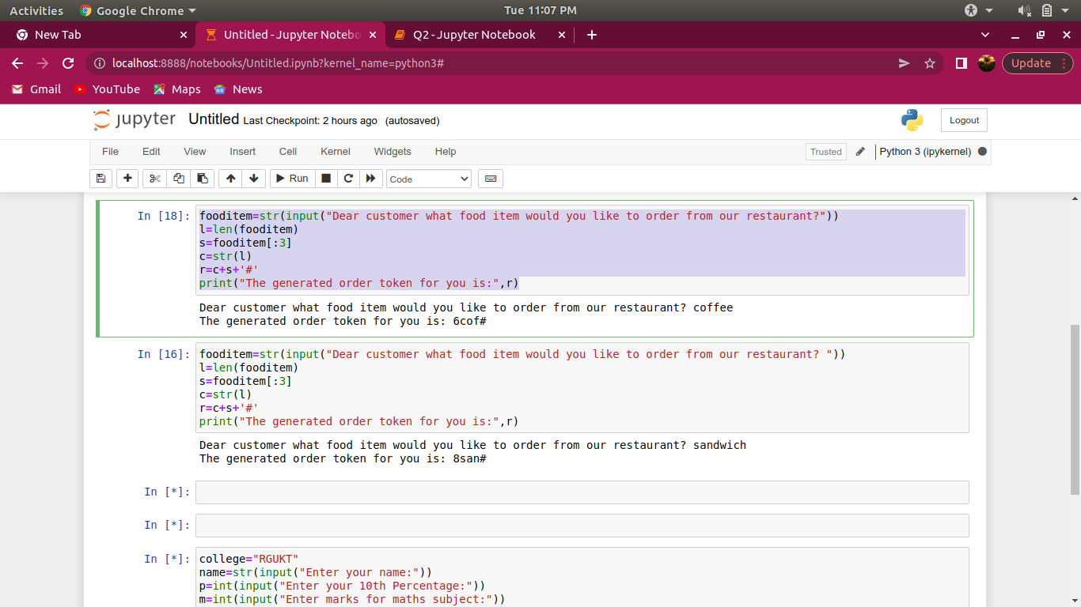

Dear customer what food item would you like to order from our restaurant? coffee
The generated order token for you is: 6cof#

4)Coding for Sandwich
Input:-
fooditem=str(input("Dear customer what food item would you like to order from our restaurant? "))
l=len(fooditem)
s=fooditem[:3]
c=str(l)
r=c+s+'#'
print("The generated order token for you is:",r)

Output:-
Dear customer what food item would you like to order from our restaurant? sandwich
The generated order token for you is: 8san#

Q2)
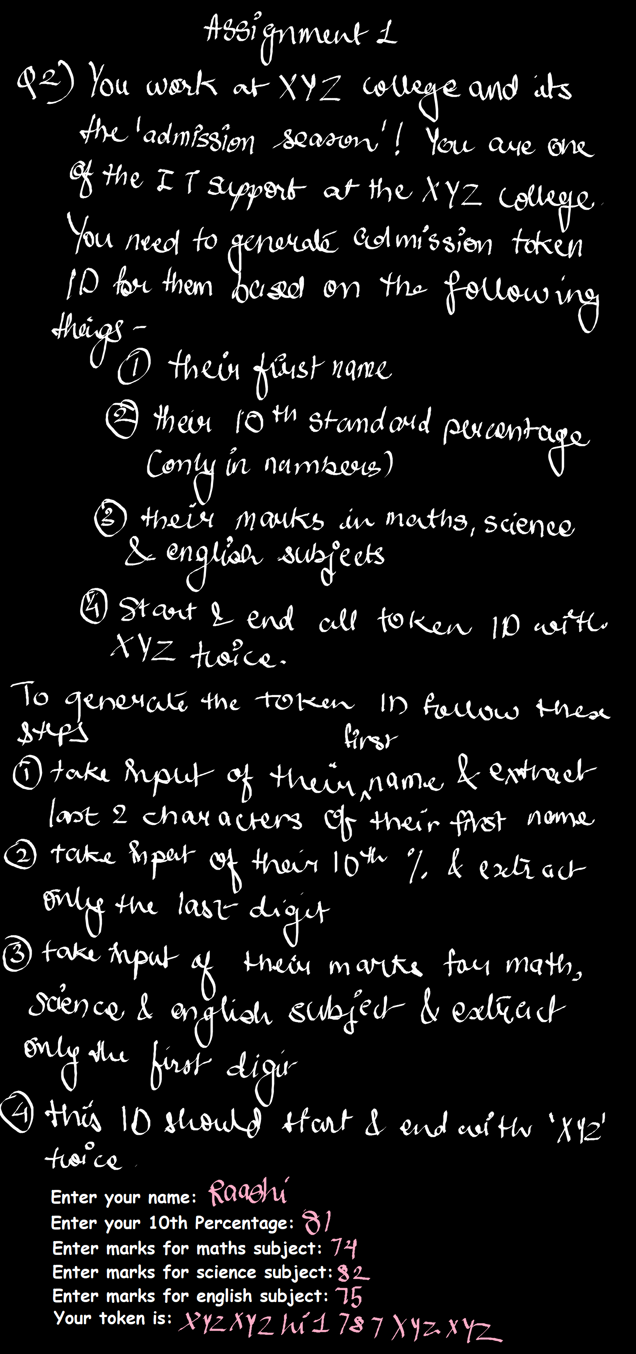
Input:-
name=str(input("Enter your name:"))
p=str(input("Enter your 10th Percentage:"))
m=str(input("Enter marks for maths subject:"))
s=str(input("Enter marks for science subject:"))
e=str(input("Enter marks for english subject:"))
x=name[-2:]
y=p[1]+m[0]+s[0]+e[0]
z=2*"RGUKT"+x+y+2*"RGUKT"
print("Your token is:",z)

Output:-
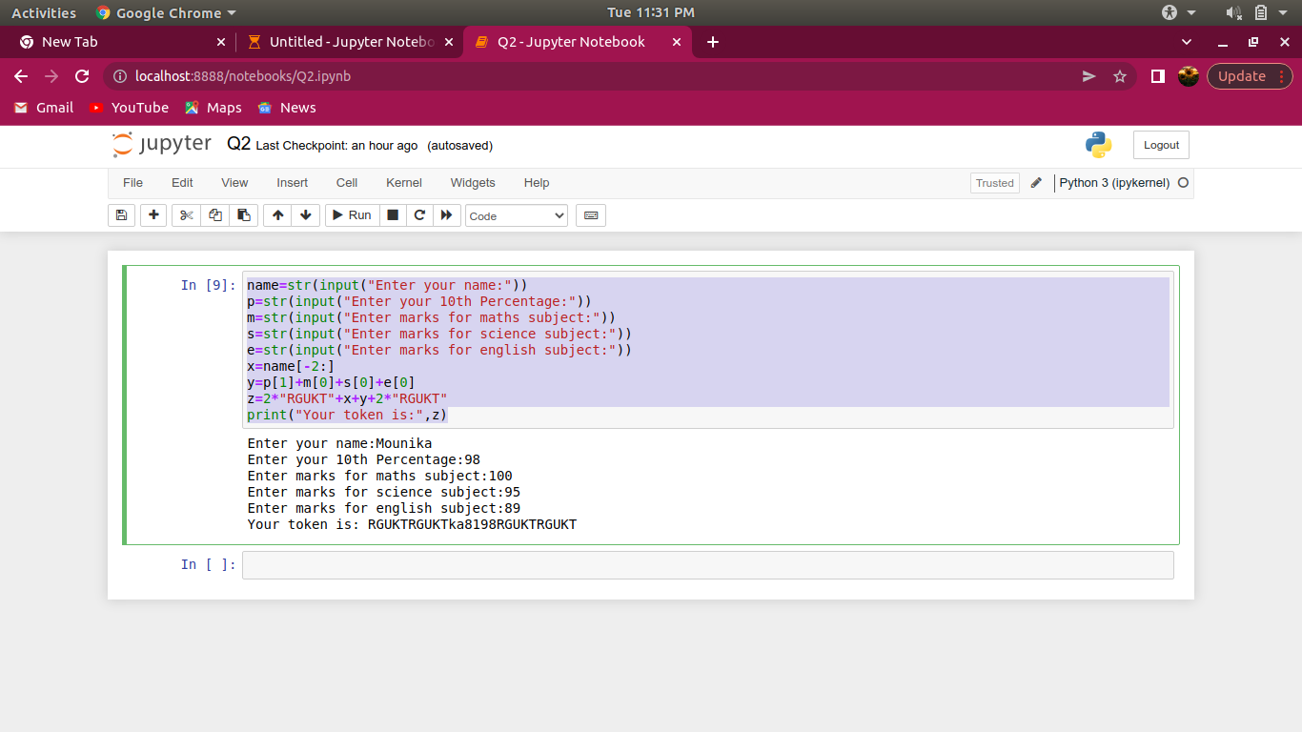
Enter your name:Mounika
Enter your 10th Percentage:98
Enter marks for maths subject:100
Enter marks for science subject:95
Enter marks for english subject:89
Your token is: RGUKTRGUKTka8198RGUKTRGUKT

